LARC Continuous Quality Improvement (CQI) Clinic Lab Interface (CLI) Initiative
Overview

Elevator Speech – What is LARC? And Why engage in LARC?

This project is about:
- An improvement collaborative working across the Clinic-Laboratory interface, focused on improving Viral Load Coverage for HIV Clients

As a result of these efforts:
- Patients / Clients with HIV will know their viral load and ultimately receive appropriate therapy

It’s important because we are concerned about:
- Meeting Viral load Coverage targets in accordance with National Guidelines
- Ultimately, appropriate care for all leading to HIV disease control

Success will be measured by showing improvement in:
- Viral load coverage
- Achieve targeted viral load turn-around time (TAT) from the labs

What we need from you:
- Consider being a part of this important QI collaborative initiative

Structure

This is a Quality Improvement Collaborative which may be presented in person or adapted for online training using the ECHO model. The output of the collaborative will be a completed quality improvement project. The LARC initiative provides a guided approach to these projects, connecting the didactic curriculum to quality improvement project deliverables. The LARC initiative provides the how-to of quality improvement.
To adapt the LARC quality improvement collaborative to the virtual/online or ECHO model, the concept of a flipped classroom is utilized in order to support interactive online sessions with case study presentations. The didactic content is accessed online prior to the ECHO learning session. The ECHO sessions are reserved for case presentations shared with the online clinic-laboratory community for democratization of learning.
These eight online sessions are scheduled over a 3–4-month period. (See graphic)
The learning comes through completing a quality improvement project using proven quality improvement tools. The teams learn by doing. The stepwise, guided learning leads to completion of specific deliverables at each session, and ultimately a completed QI project.

= Action Periods producing specific deliverables

LARC Collaborative Metrics

Goal #1 - To strengthen the clinical and laboratory project metrics, i.e., Viral Load Cascade to achieve better patient results (viral load suppression)
Do the changes implemented at each site improve service delivery?
Measured through the Clinical and Lab Aims / Metrics

Clinic Goals – Aims & Metrics: | Lab Goals – Aims & Metrics:
- Decrease proportion of High viral load patients/clients with missed clinic appointments.  - Increase proportion of sample results recorded in patient/client record.  - Increase number of VL samples drawn in eligible clients.  - Improve VL coverage. | - Increase proportion of VL samples that reach targeted Turn-Around-Times (TAT).  - Decrease proportion of samples rejected

Goal #2 - To improve Institutional Capability for Quality Improvement
Was the institutional capability for quality improvement (i.e., viral load scale-up) enhanced?
Measured through the Capability Maturity Model (CMM) & Self-Assessment of QI Skills
- Capability Maturity Model (See Appendix A): Teams would demonstrate maturation of one or more level/s over the project timeline.
- Self-assessment of QI Skills (See Appendix B): Improve the weighted average of Self-assessed QI skills and knowledge over the project period.

Goal #3 – To Achieve Learning Session Satisfaction
Were the participants satisfied with the learning sessions and curriculum materials?
Measured through surveys.
- Achievement of Intended Outcomes: 60% of participants will indicate that their outcomes were well achieved.
- 60% of participants rate satisfaction as excellent at the close of each Online Session (in the one-question poll).
- 60% of participants rate satisfaction as excellent with the sessions in the Final Survey.

Goal #4 – Collaborative Participation / Completion of Quality Improvement Project
Did the participants meet the requirements of the collaborative, including session attendance & participation, site visits, and completion of a quality improvement project?
Collaborative Dashboard
Participant Identification | IHI Courses | Session Pre-Work | Attendance @ Session | Project Deliverables Submitted on Time | # of Site Visits (SV) Conducted / # of Sites | Site Visit Reports Submitted / # SVs | Data Submission on Time | Data Quality

Collaborative Leadership – Support & Accountability Structure

Role | Identity / Responsibilities
Continuous Quality Improvement (CQI) Faculty | Define Criteria for “Faculty”/ Identify persons as such  Responsibilities:  - Review ALL Project Presentations  - Evaluate  - Provide Feedback  - Select PPTs for presentation at live sessions  - Live (or Virtual) Sessions  - Take roles at Live Sessions – Welcome, Interview participants, Provide “QI Tip of the Week”, Provide “Learning Bursts” (Didactic Training)  - Monitor Chat Box - Surface questions, reply to questions  - Provide coaching and mentorship for CQI coaches  - Accompany coaches on site visits  - Provide didactic and hands-on learning, i.e. conducting process mapping activities,  - Coach/mentor site visit activities, i.e. reviewing QI projects, coaching teams to correct Project PPT presentations, etc.
CQI Coaches | Define criteria for “Coaches” / Identify Persons as such  Responsibilities:  - Participate in LARC CQI Collaborative  - Meet key personal curriculum metrics – IHI courses, LARC Videos, Quizzes, Attendance  - Coach / support / assume responsibility for site-level QI projects  - Site Visits  - Complete required number of site visits  - Provide written reports of on-site coaching activities  - Meet key project metrics – Project deliverables, Data Submission  - Meet key site-level curriculum metrics – IHI courses, LARC Videos, Quizzes, Attendance (if required)  - Scale-up of LARC CQI  - Spread the LARC CQI CLI initiative  - Providing site / project mentoring  - Project ECHO hubs / sub hubs – preparing case studies  - Reviewing site PPT presentations  - Participate in Coaching Network  - Attend monthly Coaching Network meetings  - Present Coaching cases  - Network with other coaches for collaborative learning
Project ECHO  Staff (required if subscribing to Project ECHO model) | - Would require all ECHO specified positions  - Would require ECHO data tracking and submissions  - Proposed metrics include: (See Collaborative Dashboard - Chapter 3, Goal #4) IHI attendance, completion of session pre-work, attendance at each session, project deliverables submitted on time, number of site visits conducted out of all eligible sites, number of site visit reports submitted out of all eligible reports, data submission on time, and data quality

Collaborative Participants

- Quality Improvement (QI) Coaches (Complete online curriculum)
- Lab & Clinic Partners – those involved with collecting data and producing QI results; anyone who supervises coaches
- MOHCC – those who supervise or are involved in oversight to lab and clinic sites in the collaborative
- Facility-level staff (Modified online curriculum)

Commitments Required for Participation

Requirements | Details | Time Required
Pre-Work | IHI Videos (7 courses – Completed prior to beginning all the ECHO sessions) | 7 Courses – 1.5 hours per video
 | Didactic Videos with accompanying quizzes – LARC Curriculum content – flipped classroom, completed prior to each session, Library @ larccqi.org | 1 hour of video prior to each session – 8 sessions total
A Quality Improvement (QI) Project | Complete a QI Project | 2-4 hours per week for the length of the collaborative (12 weeks)
 | QI Deliverables Assigned per Schedule as outputs of the QI project work
Learning Sessions (In-person or Virtual) | Attend ECHO Online Sessions* | 1.5 hours per session – 8 sessions total, held every other week
 | Case Presentations – as requested during the ECHO sessions
* If cannot attend the virtual / ECHO sessions in person, then required to watch and complete a quiz to attest to participation.

Curriculum and Schedule

Coaches’ Level Curriculum

Purpose:
To build capacity to lead and coach QI projects by:
Provide a comprehensive level of (QI) didactic training for coaches
Provide guided expertise and support for completing a quality improvement project
Provide the training on a just-in-time schedule related to project completion

Scope:
Coaches / supervisors who support QI efforts in facilities:
Where there are beginning or ongoing QI projects
Where site visits are provided to support QI efforts
Have responsibility for overseeing / completing QI projects
Participate in in-person or virtual learning sessions where knowledge and cases are shared

LARC Coaches Training – Schedule

Session Date | Topic | Pre-Work*  Due prior to Session | Deliverables  Due 7 days prior to Session
Pre-Session | Program Introduction Overview of program to include expectations and time commitments | IHI Courses (7)  LARC Videos*  INTRODUCTION (5) | IHI Certificates
Week 1 | Orientation | LARC Videos*  DEFINE – (2)  Stakeholder Analysis & Team Formation
Week 2 | DEFINE –  SMART START | LARC Videos*  DEFINE (7) Remainder  PROJECT MANAGEMENT - Optional | Baseline Data (if possible)  Team Formation  Stakeholder Analysis
 | DEFINE –  SMART START  On-Site | LARC Videos*  MEASURE (ALL) | OUTPUTS of Smart Start:  Project Outline  Problem Statement & Aim Statement  Elevator Speech  Process Map & Table  I/E Grid  Just Do Its
Week 4 | DEFINE / MEASURE | LARC Videos*  ANALYZE (All) | OUTPUTS of Smart Start  VOC
Week 6 | MEASURE /ANALYZE | LARC Videos*  IMPROVE (ALL) | Data Collection Plan  Baseline Data Run Chart  Fishbone / 5 Whys
Week 8 | IMPROVE / CONTROL | LARC Videos*  CONTROL (All) | Lean – 5S
Week 12 | Project Presentations |  | 2 or more Tests of Change (PDSAs)
Week 13 | Project Presentations |  | 2 or more Tests of Change (PDSAs)  Standard Work – (SOP)  Future State Map
Week 15 | Final Project Report Out |  | Control Plan  Final Project Report
*LARC Videos/Quizzes – Approximately 1-2 hours of pre-work per session. Videos @ larccqi.org

The Facility Level Curriculum

Purpose:
To Assist facility staff to participate meaningfully in facility-level QI projects by:
Providing an introductory level of (QI) didactic training for team members
Provide the training on a just-in-time schedule related to project completion

Scope:
Healthcare workers in facilities:
Where there are beginning or ongoing QI projects
Where there is coaching support provided for QI projects, including site visits
Where they are participants in facility-level teams responsible for QI projects
May or may not participate in the training sessions (in-person or virtual)

LARC Facility-Level Training – Schedule
Associated Training Session | Training Session Topic | Video Didactic Sessions*  Completion Due prior to Session | Deliverables  Due 7 days prior to Session
Pre-Session | Program Introduction Overview of program to include expectations and time commitments | IHI Courses (7) – (Optional)  LARC Videos*  INTRODUCTION (3)  0.1 Why, 0.3 What, & 0.4 Concepts | IHI Certificates (Optional)
Week 1 | Orientation | LARC Videos*  DEFINE – (2)  1.1 – Overview & Problem Statement & 1.2 – Project Outline, Aim Statement, & Elevator Speech
Week 2 | DEFINE –  SMART START | LARC Videos*  DEFINE (3)  1.6 – Process Mapping (PM), 1.7 – PM Smart Start, 1.8 – Intro to Smart Start | Baseline Data (if possible)  Team Formation  Stakeholder Analysis
 | DEFINE –  SMART START  On-Site | LARC Videos*  MEASURE (1)  2.1 - Overview | OUTPUTS of Smart Start:  Project Outline  Problem Statement & Aim Statement  Elevator Speech  Process Map & Table  I/E Grid  Just Do Its
Week 4 | DEFINE / MEASURE | LARC Videos*  ANALYZE (2)  3.1 – Overview, 3.2 Fishbone & 5 Whys | OUTPUTS of Smart Start  VOC
Week 6 | MEASURE /ANALYZE | LARC Videos*  IMPROVE (4)  4.1 – Overview, 4.3 – PDSA Concepts, 4.4 – PDSA Examples, 4.5 Lean | Data Collection Plan  Baseline Data Run Chart  Fishbone / 5 Whys
Week 8 | IMPROVE / CONTROL | LARC Videos*  CONTROL (1)  5.1 - Overview | Lean – 5S
Week 12 | Project Presentations |  | 2 or more Tests of Change (PDSAs)
Week 13 | Project Presentations |  | 2 or more Tests of Change (PDSAs)  Standard Work – (SOP)  Future State Map
Week 15 | Final Project Report Out |  | Control Plan  Final Project Report
*LARC Videos with Quizzes – Approximately 30 minutes of pre-work per session

Proposal for Long-term Sustainability of Continuous Quality Improvement (CQI) at the Clinic Lab Interface (CLI)

APPENDICES
APPENDIX A – Capability Maturity Model (CMM) – Viral Load Cascade

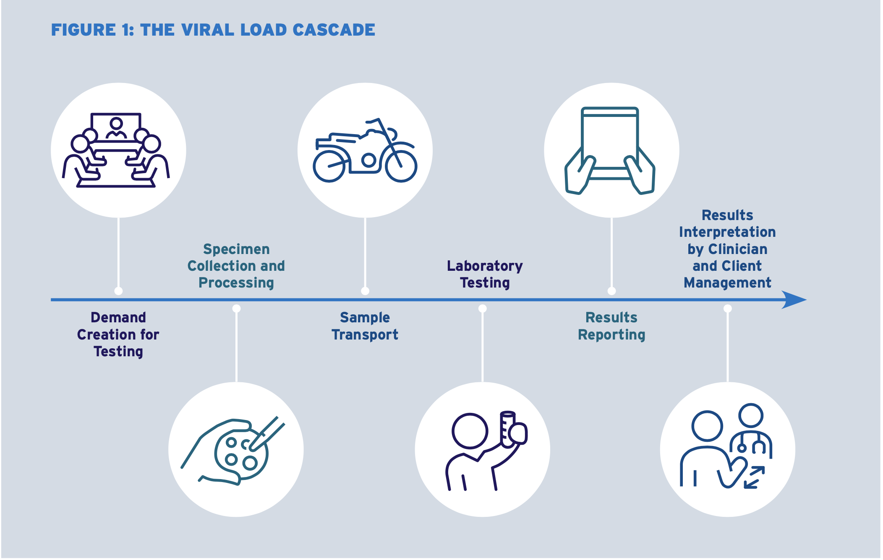

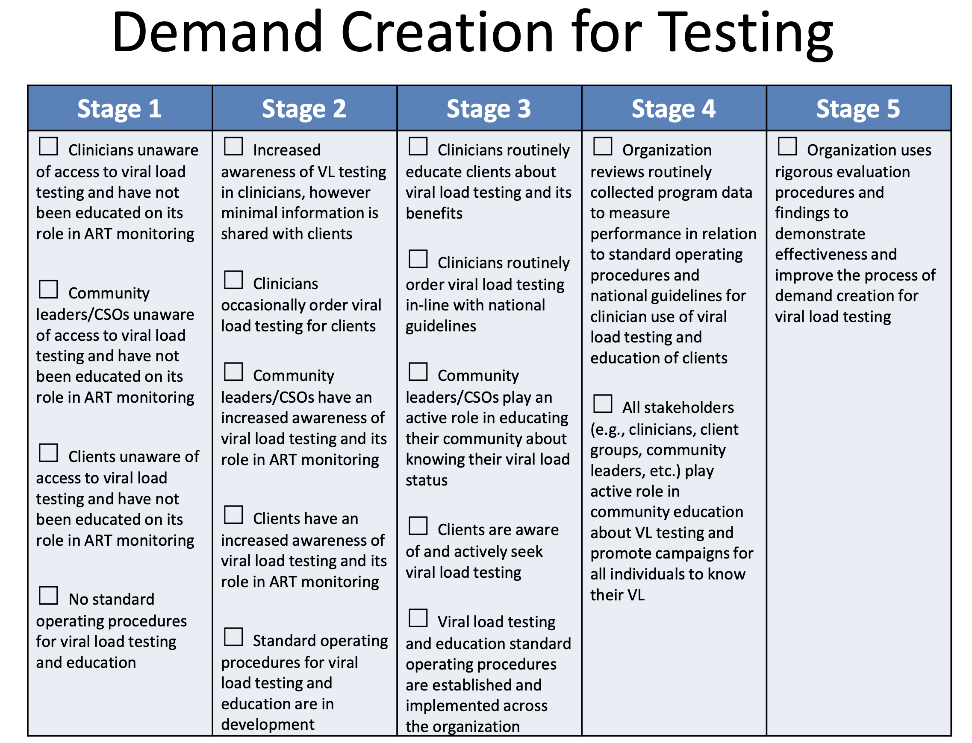

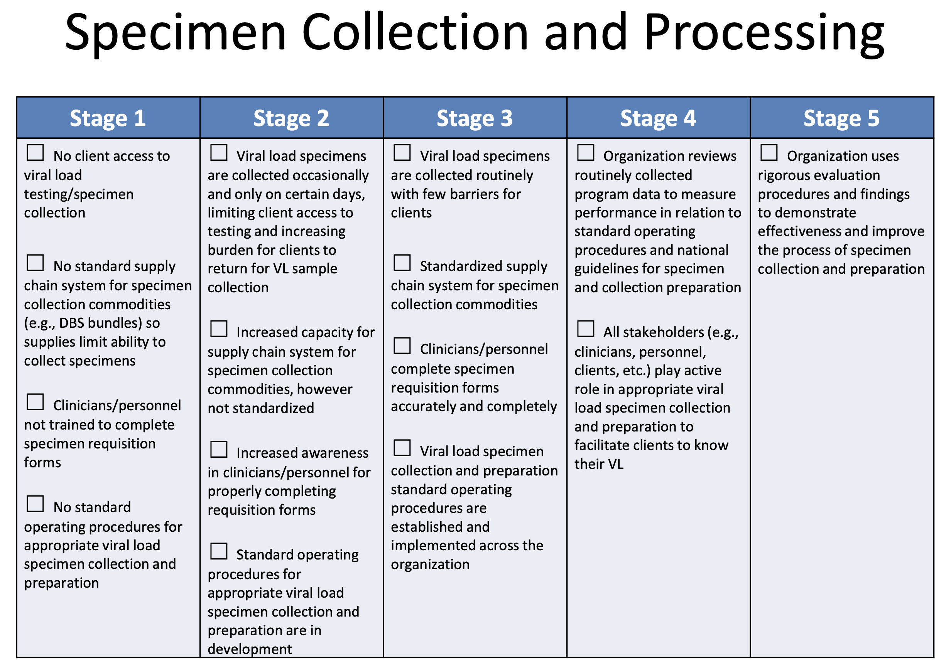

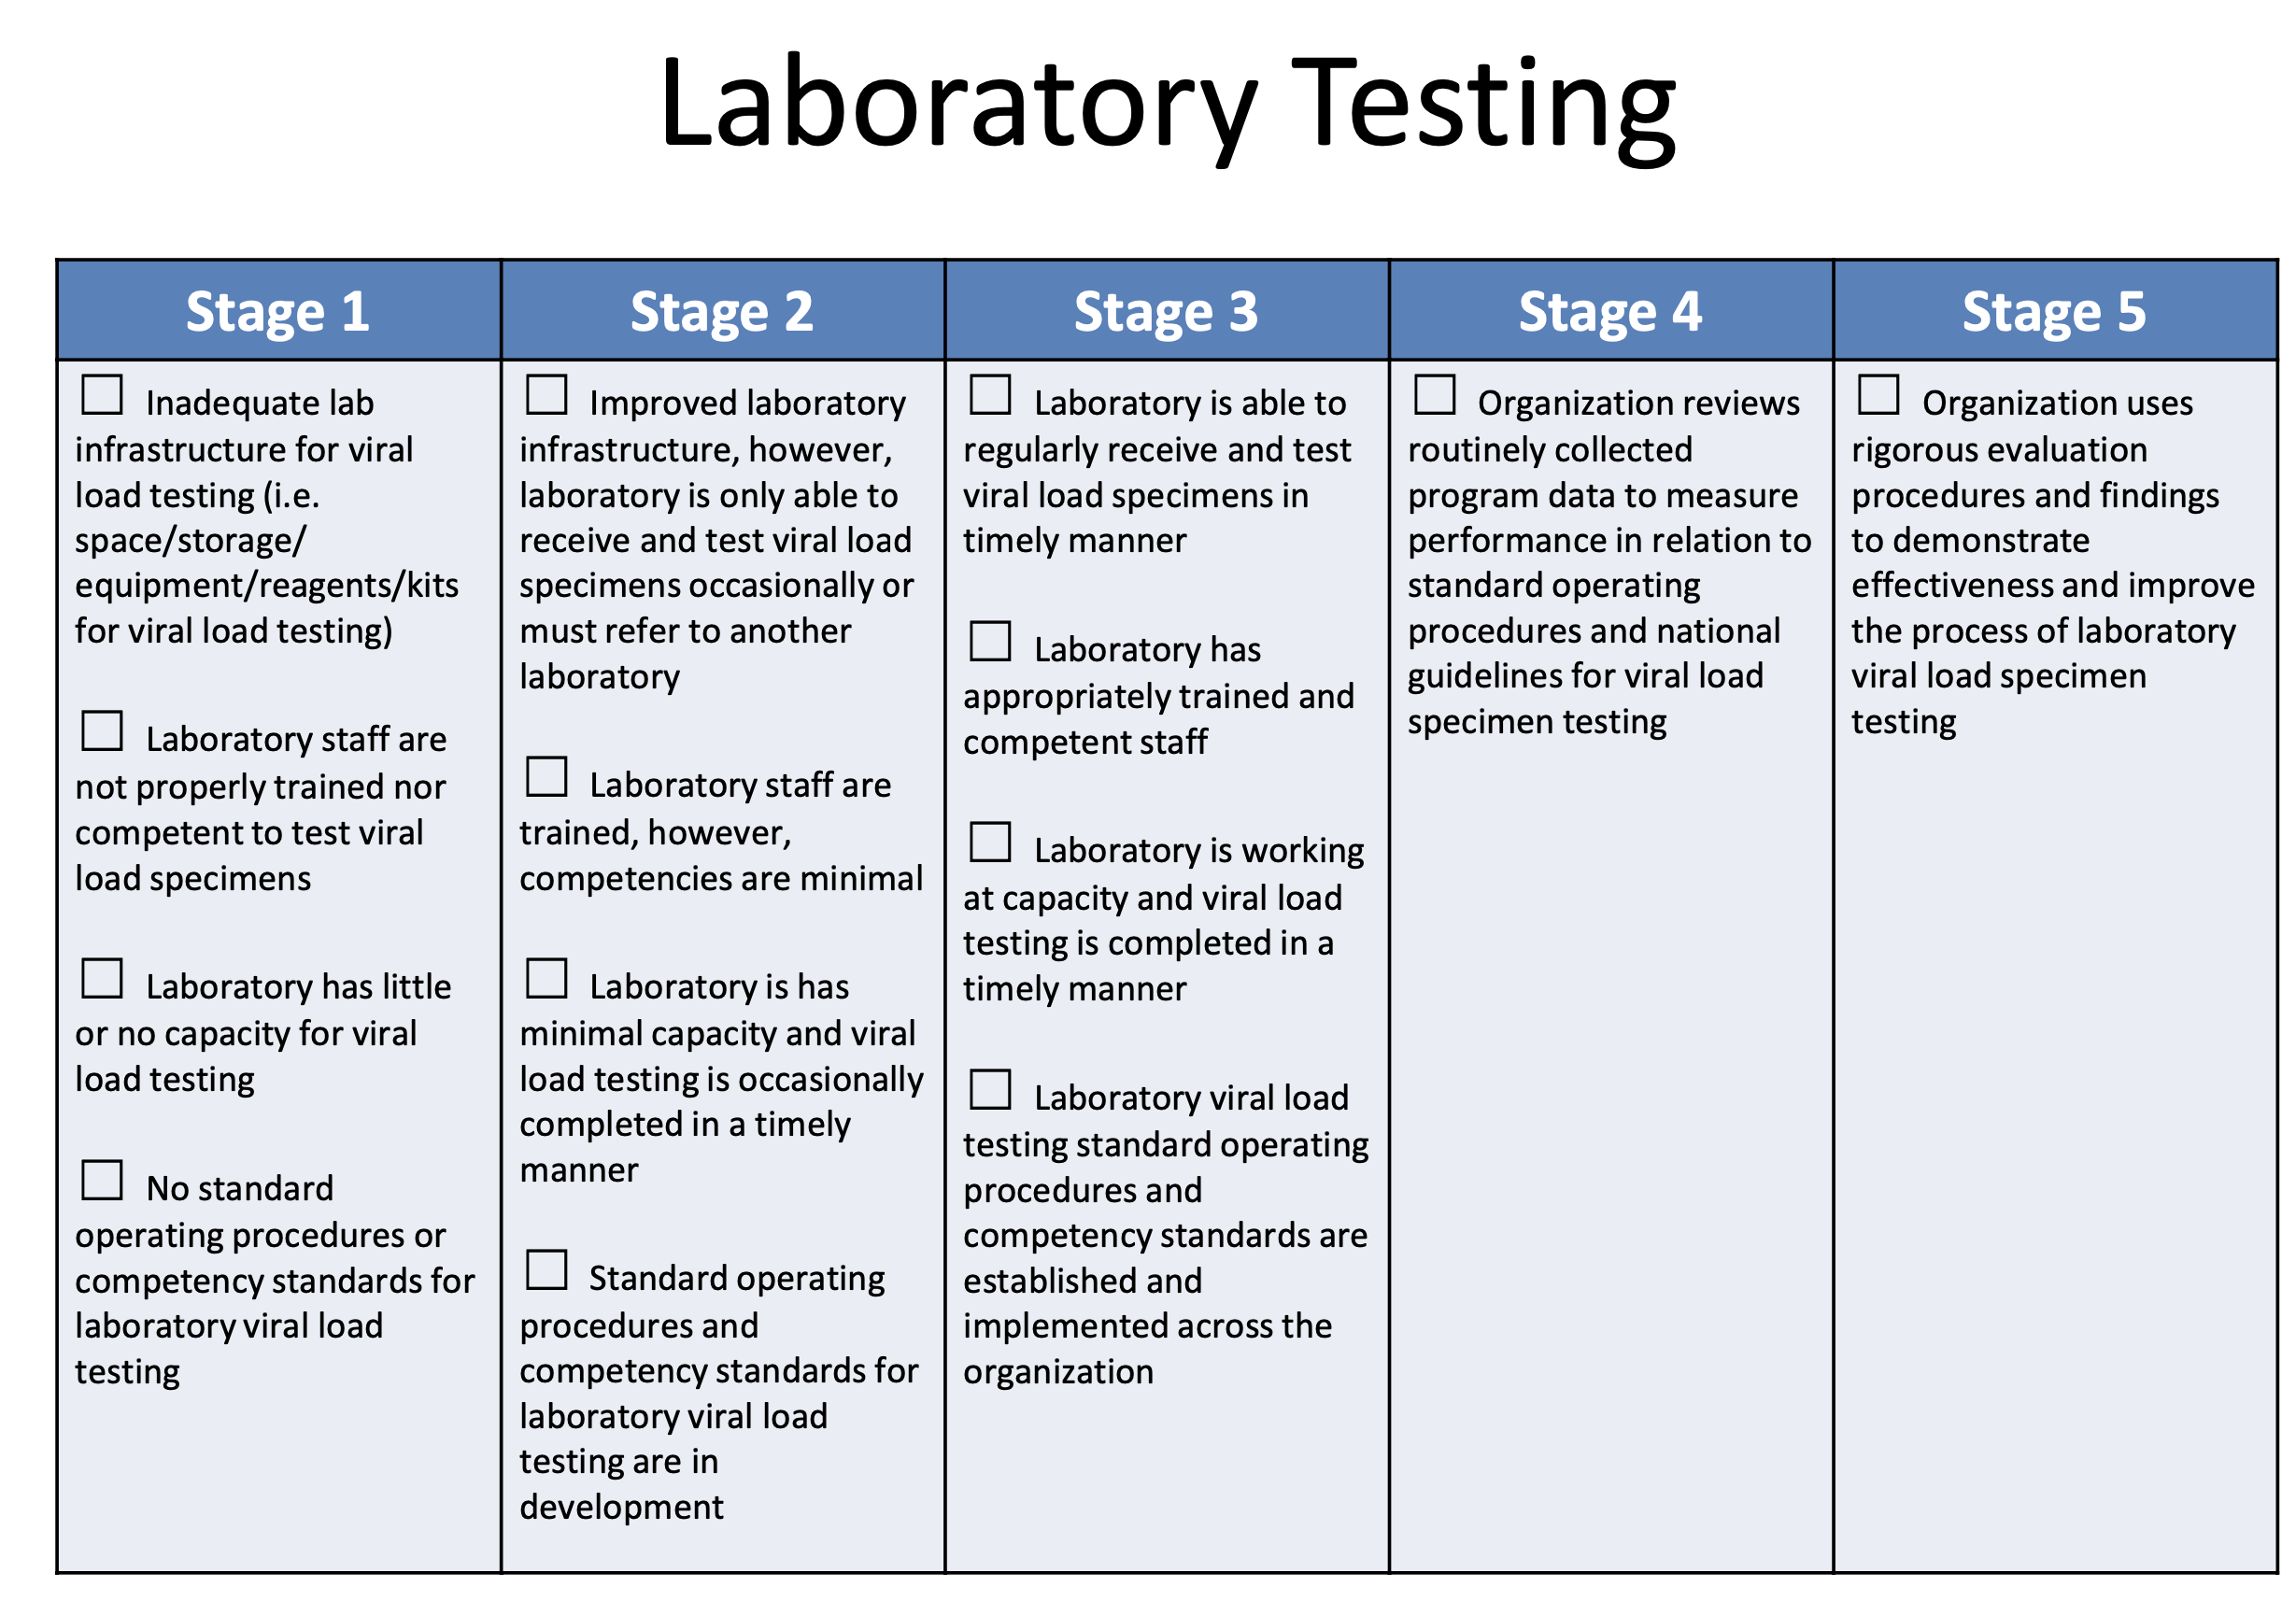

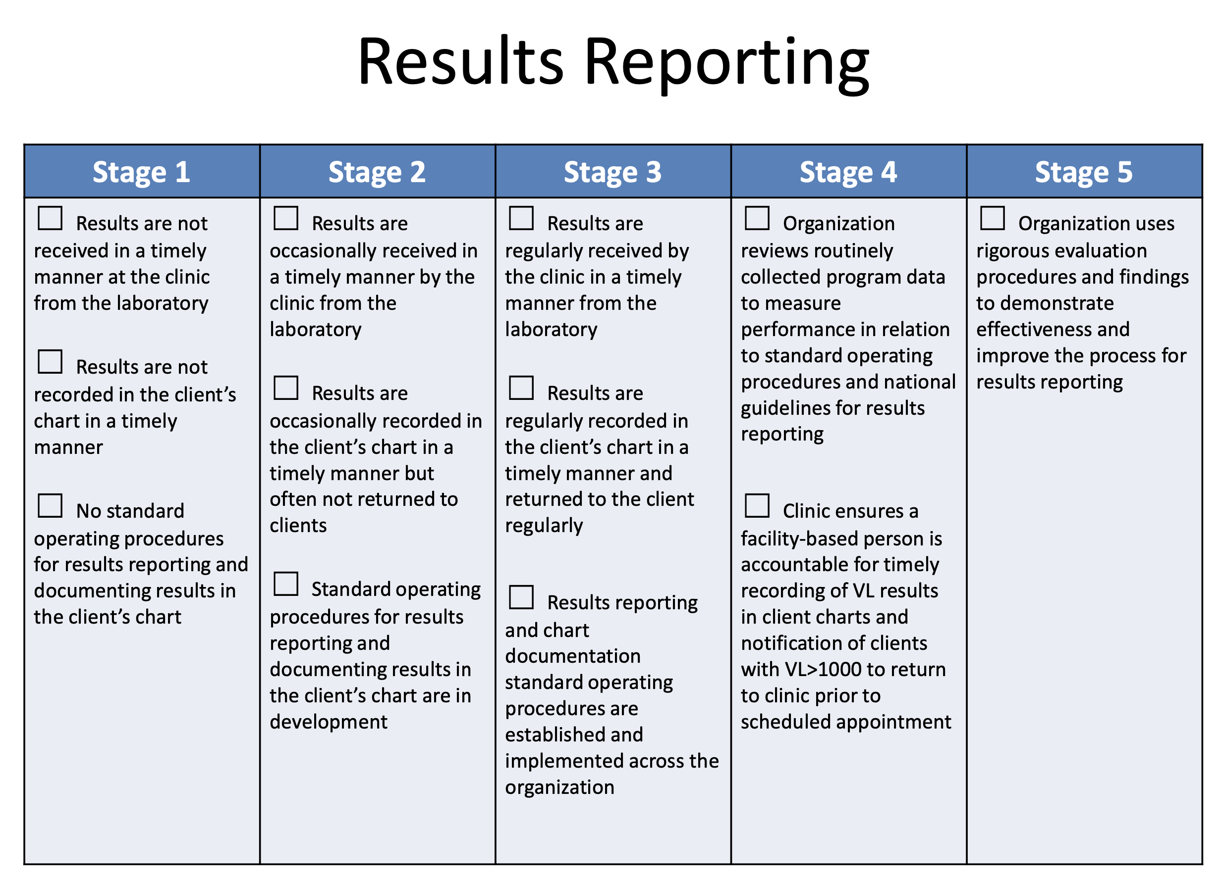

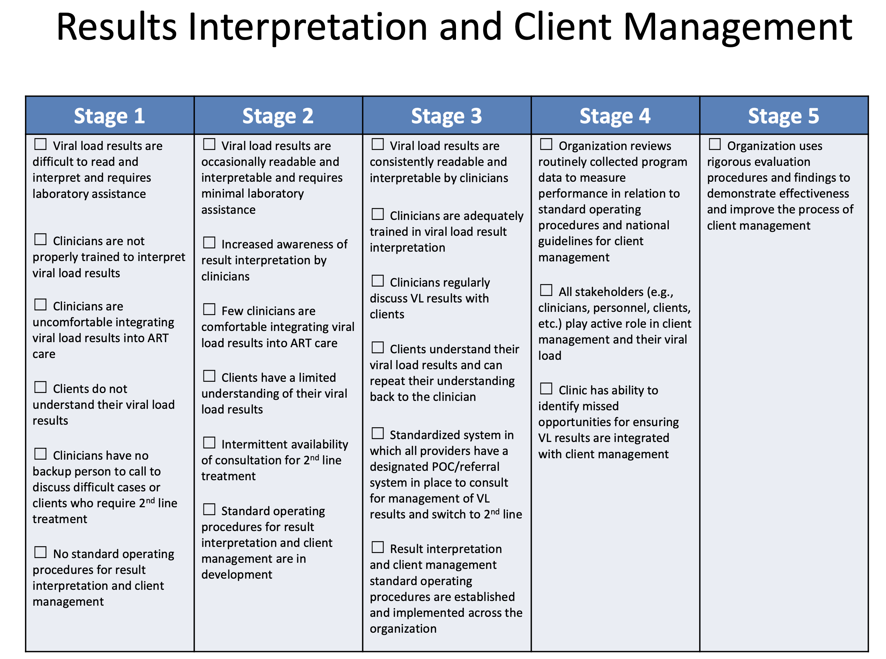
APPENDIX B – Self-Assessment of Quality Improvement Skills & Knowledge
Self-Assessment of Quality Improvement (QI) Skills & Knowledge*: Asks participants to retrospectively self-assess their QI knowledge & skills BEFORE LARC CQI and AFTER LARC CQI, based on the following definitions.
*Definitions for the Assessment of QI Skills/Knowledge
Knowledge / Skill Level | Definition
Novice | New to QI; no QI knowledge or experience
Beginner | Limited implementation experience and/or knowledge with/of some tools, such as 5S or PDSA
Intermediate | Used the full DMAIC approach on one or more QI projects
Advanced | Experienced with DMAIC with multiple projects, and have coached others

