Project Management Tools

Five practical tools to ensure the project stays on track and is completed successfully

Learning Board
A bulletin board that serve as a key communication tool for the project

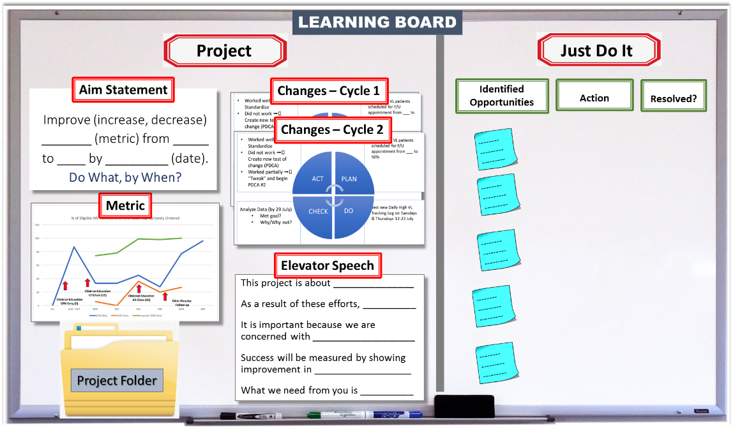
WHY
- To make the project visible to all, including aims and metrics over time
- To create understanding and engagement for the project from all the staff
- To encourage staff input – Opportunities for improvement (OFIs), Concerns, Ideas, etc.

WHEN
Throughout the project

HOW TO
- Obtain a dedicated board & mount on wall
- Divide the board (with color tapes) and label each section according to the above example
- Populate the sections of the board with the appropriate material and update throughout the project
Project Side
  - Project Aim Statement
  - PDSA Cycles – Each test of change outlined
  - Metric – Run Chart
  - Project Folder – Repository for project documents
  - Elevator Speech – Key messages for the project

Just Do It Side
  - Opportunities for Improvement (OFI) - Place all sticky notes generated from the process mapping activity in the first column
  - Actions - Physically move each sticky note to second column as these items are acted upon.
  - Resolved - As items are resolved, physically move to third column
  - Spreadsheet - After time for all team to see that the items are resolved, transfer to a spreadsheet that catalogues all completed items. If items are not able to be resolved at the current time, let team know that these items are not feasible at this time and why.
- Encourage team to continue to generate opportunities for Improvement (OFIs) throughout the project and beyond
- During team meetings
- Project Side - Review & update data, share PDSA cycles, clearly let the team know what is needed from each team member during the tests of change
- Just Do It Side - Evaluate any new OFIs and update any actions taken and issues resolved

Project Folder
The central repository of project knowledge

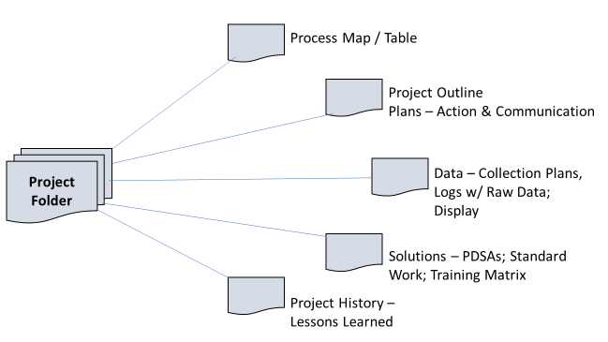

WHY
- A repository for the complete project documentation – from outline to final results, including all tests of change - in one central location
- To keep raw data for team review and assistance with analysis and display

WHEN
Throughout the project

HOW TO
- Obtain a physical folder
- Mount on learning board
- Place all required elements in the folder

Meeting Facilitation
Meeting facilitation is a process that ensures meetings are conducted efficiently and effectively to achieve project goals
WHY
Meetings, when used appropriately and effectively,
- Keep the team focused on defined project goals, aims and timelines.
- Serve as a key communication tool for team members to inform each other about the project progress, successes, and challenges.
- Drive project implementation regarding planning & follow-up actions to meet project outcomes

WHEN
Meetings should be held regularly throughout the project period. Frequency depends on the project phase and timeframe: More frequently (e.g., weekly or bi-weekly) in the early phases of the project or if the overall project timeframe is shorter

HOW TO
Before the Meeting
- Determine meeting objectives (problems to be solved; topics to be discussed, brainstormed, or debated; consensus to be reached; team decisions to be made; camaraderie/teamwork to be enforced) by reviewing the following:
  - Project progress in relation to the project aims
  - Ongoing activity – tests of change
  - Data Collection & Display
  - Outstanding Action Items
  - Information needed
  - Challenges & Barriers
  - Next steps, direction of project
  - Items for discussion / Decisions to be made
- Develop meeting agenda
- Determine who should attend the meeting:
  - Mandatory for all core team members
  - Invite others as necessary based on specific meeting objectives
- Create meeting materials (presentations or handouts), if necessary
- Engage or invite stakeholders as needed
- Complete logistical details – location, date, time, place, transportation & Invitation
- Send out the agenda and materials in advance so people come ready to participate
- Assign a meeting note taker
During the Meeting
- Manage time effectively, adhering to pre-determined times, to assure meeting goals are achieved
  - Beginning - Spend only a short time orienting participants to meeting goals and materials
  - Middle - Spend most of the meeting time on group discussion
  - End – Complete action plan, confirming clear understanding of next steps by all – who is going to do what by when

After the Meeting
- Send meeting minutes
- Communicate to team members who did not attend the meeting
- Communicate to Stakeholders as directed by Communication Plan
- Make sure next meeting is on all team member’s calendar
- Follow-up on action items

TIPS
- Create a group calendar
  - Determine all the meeting time/dates at the start of the project. People tend to remember the meetings better if they occur at the same time on the same day at a regular frequency. Set meeting dates while the team is together in person such as at the Smart Start session in the beginning of the project.
  - Make sure all meetings dates are populated on team members’ calendars.
- Keep the meeting focused - Invite only the people who need to be at the meeting.
- Keep the meeting short - 60 minutes usually, 90 minutes if agenda warrants.
- Keep the meeting action oriented - Make sure next steps/action items include the three “Ws” - What/Who/When. Clearly articulate these action items at the close of each meeting and in the meeting follow-up communications.

Templates:
Select one or more of the following templates, based on meeting type, objectives, and project needs:
- Meeting Agenda
- Project Update
- Meeting Minutes
- LARC Conference Call Agenda

MEETING AGENDA

(Title) |  |  | [Date]  [Time]  [Location]
Meeting called by: |  | Type of meeting:
Attendees:

Agenda Items
Topic | Action Item |  |  | Person Responsible | Deadline

Notes:

Next Meeting:

PROJECT UPDATE

DATE: | PROJECT STATUS REPORT | AIM:
Accomplishments: | Metrics Summary
Current Priorities | Top Challenges & Issues | Action Items
Next Meeting | Important Dates

MEETING MINUTES

[Meeting Title]
[Pick the date] |  | [Meeting Time] |  | [Meeting Location]
Meeting called by
Type of meeting
Facilitator
Note taker
Timekeeper
Attendees
[Agenda Topic]
[Time allotted] | [Presenter]
Discussion
Conclusions
Action Items |  |  | Person Responsible |  | Deadline
[Agenda Topic]
[Time allotted] | [Presenter]
Discussion
Conclusions
Action Items |  |  | Person Responsible |  | Deadline
[Agenda Topic]
[Time allotted] | [Presenter]
Discussion
Conclusions
Action Items |  |  | Person Responsible |  | Deadline

LARC CONFERENCE CALL AGENDA
Monthly Project Phone Follow-up

Date:
Time:
Site/Country:
Call Attendees:
AIM Statement:
Intervention:

Agenda | Update | Suggested Follow-up Actions
Current Situation Update
Changes Implemented in Last Month
Data Review
Successes
Challenges
Next Steps

Action Plan
A detailed plan outlining actions needed to reach one or more goals

WHY
- To assure project stays on track and is ultimately successful
- To clearly communicate what needs to be done, by whom, and by when

WHEN
- Reviewed at beginning and end of each meeting (Agenda)
- Shared as a follow-up to each meeting

HOW TO:
- Discuss and reach group consensus on next steps in terms of What, Who, and When as in the template below

Action Plan Template

Topics/Goals | ACTION ITEMS | By Whom? | By When?

Communication Plan
A road map for sharing project information with the team and key stakeholders

WHY
- To assure the team and the stakeholders are kept updated on the project
- To assure clear, timely and desired communication regarding the project

WHEN
- Created during project initiation to inform communication needs
- Implemented and revised as necessary as project progresses

HOW TO
- Based on inputs from the Stakeholder Analysis, determine which stakeholders require which information and how often they desire or require communication; Populate communication plan accordingly
- Complete each column in the Template for any item that the team deems necessary to be communicated with team members and stakeholders
- Update, if needed, after each meeting

Template:
- Communication Plan

Communication Plan

What? | To Whom? | By What Method? | When? | How Often?

