Lean Tools
Lean is an improvement methodology focused on delivering value to the customer and eliminating waste.

WHY
With limited resources in healthcare, it is inefficient and costly to expend energy, time and money on things that do not add value for the customer (i.e., waste)

Type of Waste | Example
Misutilization of Skills | Not taking advantage of people’s skills or capabilities; Not listening to or acting upon people’s improvement ideas
Reprioritization | Phone calls, emails, trouble shooting, Texts or IM pop-ups
Transport | Moving people, products and information; Going to get signatures; Moving patient records
Inventory | Storing parts, pieces, documentation ahead of requirements; Pharmacy stock, lab stock, office supplies
Motion | Bending, turning, reaching, lifting; Searching for patients, charts, medications or files; Moving patients for testing
Waiting | For parts, information, instructions, equipment; Waiting for discharge, approvals
Over Production | Making more than is immediately required; Making extra copies;
Over Processing | Multiple bed moves; Extra paperwork, excessive reviews/analysis, creating reports no one uses or reads, using out-of-date forms
Defects | Rework, scrap, incorrect documentation; Medication errors, improper diagnosis, patient complaints, data entry error, pricing error, mislabeled specimen

Guiding Principles for LEAN
Eliminate waste | To eliminate waste, you must first see the waste
Increase Value | Value is defined in terms of the customer. For what is the customer willing to pay?
Respect Expertise | The front-line workers know best how to solve front-line problems
Go and See | The improvement team must go to the work and see the actual condition

HOW TO:
- See the Waste - Identify waste using the following tools:
  - Process Mapping – Current State (see Process Mapping)
  - Waste Walk
  - 5S
  - Spaghetti Diagram/Physical Layout
- Eliminate the Waste - Once waste is identified, use the following tools to eliminate:
  - Process Mapping – Future State (see Process Mapping)
  - Waste Walk Action Plan
  - 5S
  - Spaghetti Diagram/Physical Layout
  - Visual Management
  - Standard Work
  - PDSA

These tools are explained in the following pages:
- Waste Walk
- 5S
- Visual Management
- Spaghetti Diagram / Physical Layout

Waste Walk
A planned visit to where work is being performed to observe what is happening and specifically to look for waste - to make waste visible again

WHEN
After identifying problems during the process mapping, conduct a Waste Walk to validate observations and gather front-line staff ideas about the problems and potential solutions

HOW TO
- Gather team and explain what, why, and how to of Waste Walk
  - Provide copy of the process map table with the identified problems
  - Provide a Waste Walk Template
- Walk the entire process with the team. Assign pairs at each work area to observe the process for 30-45 minutes, and record observations on the Waste Walk Template
- Talk to front-line staff, share process map with identified problems. Ask for validation of identified problems and elicit any potential solutions
- When team comes back together, discuss observations
- Collate identified wastes
  - Compare with identified problems (or OFI) from the Current State Process Map or Table
  - Update Project Action Plan with any new wastes/problems/OFIs identified and assign action items
- Follow up Action Plan routinely to assure that identified waste is eliminated

Template:
- Waste Walk
Waste Walk
Type of Waste | Observation | Possible Solutions - from People Doing the Work
Misutilization of Skills
Reprioritization
Transport
Inventory
Motion
Waiting
Over Production
Over Processing
Defects

5S
A workplace organization method that uses a list of 5 words, each beginning with S, to prescribe how to organize a work space

WHY
5S improves the efficiency and effectiveness of the work, eliminating clutter and disorganization

WHEN
In the beginning of any improvement effort, as 5S provides an immediate visual change to the workplace, inspiring staff in the promise of the entire improvement effort

HOW TO
- Choose a target area for the 5S exercise
- Engage a cross-functional team, including staff from the targeted work area; Insure that upper management is involved
- Plan for a staging area, a physical area near the target area, in which to place items that need further categorization
- Document the “BEFORE” state using the 5S Audit Sheet and photographs
- Organize and complete the 5S Exercise of the area according to the steps below
- Record the “AFTER” state using the 5S Audit Sheet and photographs

Sort | Identify & eliminate what is not needed  - Remove items from the area that have not been used recently (in the last three months)  - Red tag the unused items  - Place them in the staging area  - Have manager or team lead determine disposition: Either back to area, dispose of, or donate
Set in Order | A place for everything and everything in its place  - Identify everything in the area  - Define & label or mark off a place for each item  - Create a standard (a photo, chart, or label) to identify where items go and to make it readily visible if something is missing  - Make workflow smooth and easy  - Place frequently used items close to their place of use, relegating less used items further away
Shine | Keep the work area clean and uncluttered.  - “Spring-Cleaning” of all items in area  - Create 5S Cleaning Plan
Standardize | Develop standards and stick to them.  - Put procedures in place to make sure the first 3 Ss are consistently and reliably implemented  - Build the work structure to incorporates routine “maintenance” of the first 3 Ss into daily work activities  - Create visual controls – charts, color coding, photos, marked off areas, etc. – to assure that everything stays as it should be
Sustain | Sustain all gains.  - Conduct 5S Training  - Encourage self-discipline & accountability  - Regularly conduct 5S Audits

Templates:
- 5S Audit Sheet
- Learning Session PPT Template for Reporting 5S Exercise

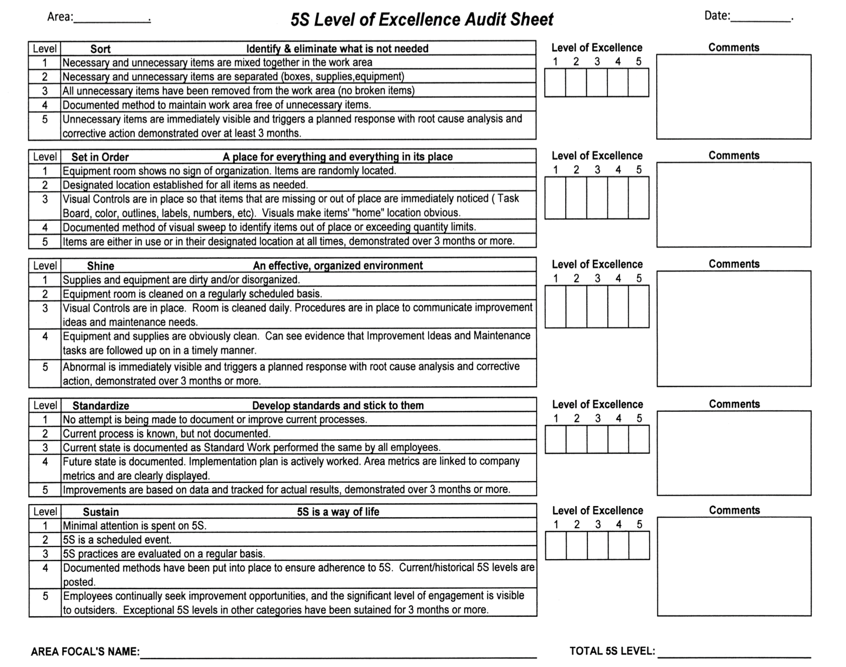

Visual Management
A variety of simple methods to make the work and processes easily visible;
May be part of a 5S Exercise

WHY
- To improve the effectiveness of communication and reaction.
- To convey messages quicker and invite more interest than written information.

WHEN
Use this tool when organizing the following areas:
- Work Areas
- Work Processes
- Storage of equipment or supplies
- Records/Files/Procedures
- Way-finding

HOW TO
Visual management may be accomplished by the following methods:
- Color coding
- Tape marking of areas / Signage
- Diagrams / Charts / Graphs / Standard Operating Procedures
- Photographs

Template:
Learning Session PowerPoint Template for Reporting Visual Management (Photograph)
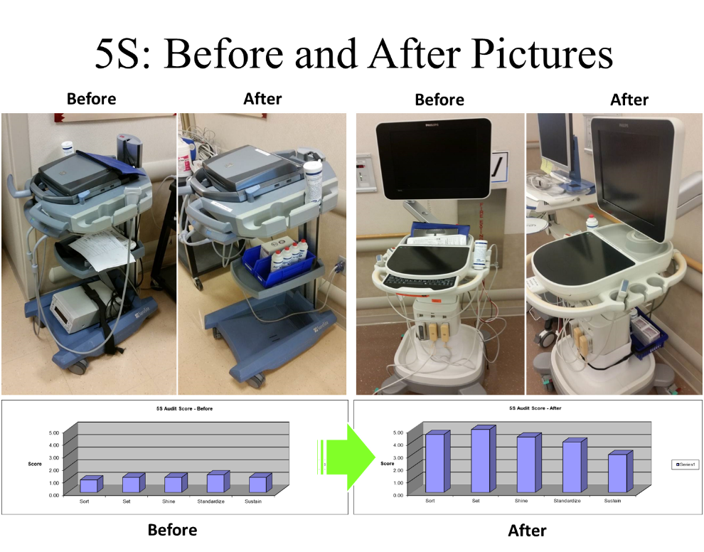
Spaghetti Diagram/Physical Layout
An observational activity resulting in a representation or drawing of the floorplan of a room and the paths taken by staff performing the steps in the process

WHY
This tool reveals the relationship between the process and the structure (physical layout), detecting transport and motion wastes

HOW TO
- Create floor plan of selected work area on flip chart
- Ask an observer to trace the path of staff in the work area using a marker
- Analyze, as a team, the spaghetti diagram
- Discusses, as a team, how to eliminate the excess transport and motion by
  - Streamlining the process – combining, removing or altering the steps
  - Redesigning the physical layout – to match the new process
- Create future state process maps, standard work and floor plan to codify the new processes

TIPS
- Use cross-training to assist in the new layout, thereby providing staff who can perform various roles, flexing as needed to maintain flow and thus accommodating the needs of the customer
- Consider creating pull systems where one workstation will “pull“ new work from the previous workstation whenever feasible, instead of having work “pushed” to the next workstation when not ready
- Focus on continuous flow, moving uni-directionally from first to last step in the process
- Remain flexible when redesigning floor plans, as updates may need to be made over time
- Establish before and after metrics (measurements) to show the improvements

Associated Activities:
- Simulation – Before/After
- Standard Work

