Brainstorming
A technique to generate ideas, input and insights from the team
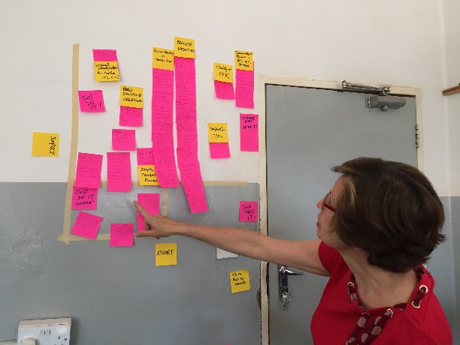
WHY
- To gather the greatest variety and diversity of ideas and insights into the problem or solutions
- To stimulate creative thinking
- To allow consideration of input from all the team
- To allow collection of ideas over a short period of time
- To group the ideas in categories or themes to facilitate organization of the brainstorming session
- To evaluate how many people identified a particular opportunity, idea or solution – to assign a degree of consensus or numerical “vote” to each option

WHEN
- Define Phase - Post Process Mapping - to gather Opportunities for Improvement (OFIs) that the team identified as they walked the process
- Analyze Phase - With the Cause & Effect Diagram to explore potential causes
- Improve Phase – With the Impact-Effort Grid to prioritize potential solutions

HOW TO
- Gather all team members or activity participants & describe the goal of the session
- Provide all participants with multiple self-stick notes
- Ask participants to write their input on the self-stick notes, one OFI, cause or solution per note
- Place all notes on flipchart, board or wall
  - Defer discussion until all ideas are shared
- Proceed to group or collate the responses according to similar topics, categories or themes (also called an affinity diagram)
  - One or two people (preferably the facilitator and/or team lead) to begin reading and organizing the notes
  - Group similar notes – forming groups with similar themes
  - Clarify any ideas not clear
  - Capture any new ideas that are stimulated as the ideas are shared
  - The team may be asked to assist in the titling of the groups
  - Count & note the number of notes in each group
- Ask the participants about their reaction to the ideas generated
  - Any surprises in the responses?
  - Agreement with the most mentioned ideas?
  - What actions, if any, will be generated?
- This activity can provide inputs toward creating:
  - Opportunities for Improvement (OFIs)
  - Cause & Effect Diagram
  - Impact Effort Grid

TIPS
- Encourage all to participate with at least one note per person
- Encourage as many ideas/notes as possible
- When working on solutions, encourage unfettered thinking that may be “outside the box”, innovative, big, impossible, or audacious ideas
- Do not criticize or dismiss any idea
- For ease or organization, use a different color self-stick note to title the affinity groups so ideas and corresponding numbers of notes (votes) can be seen by the team

Associated Tools:
Cause & Effect Diagram
Impact-Effort Grid

