Voice of the Customer (VOC)
An in-depth process, using both qualitative and quantitative research, to systematically listen to the customers, use the information to take action, and monitor performance over time

WHY
Quality must be defined for each product or service based on what the customer wants. Understanding their wants, needs and aversions is crucial as they are the key inputs for the new process or product, and will lead to improved customer experience, reduction in re-work and service recovery, and increased staff engagement.

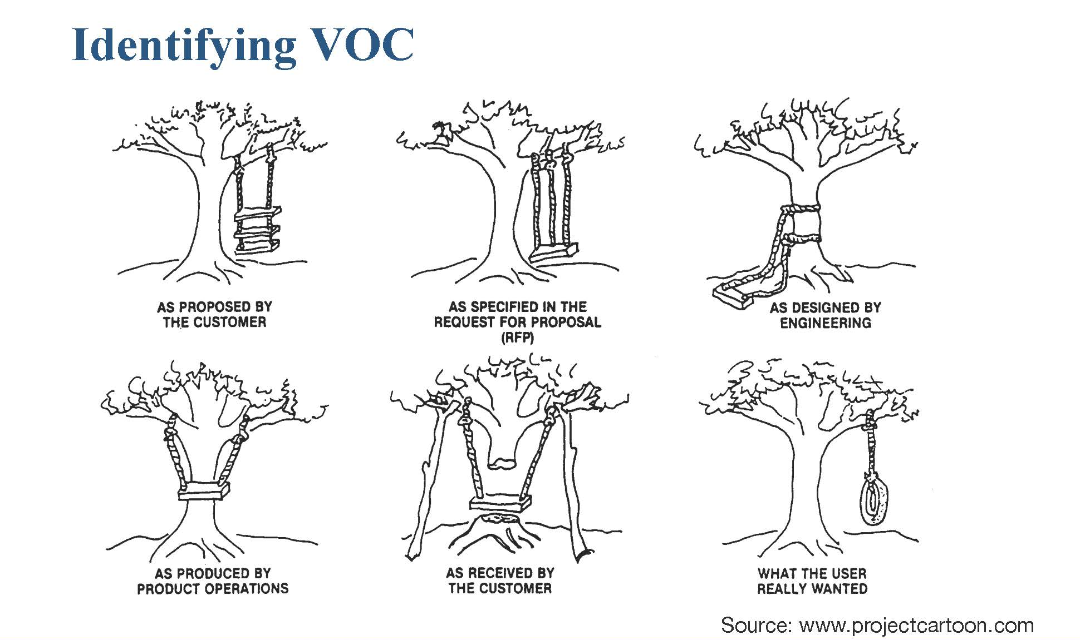

WHEN
Voice of the Customer (VOC) studies are conducted at the start of any new product, process, or service design initiative (Define/Measure) to clarify and prioritize customer needs. VOC may also be used in the Improve Phase to test changes and seek feedback on potential solutions.

HOW TO
Listen to Customers - Gather information about the customers and their experience with the current process/product or alternatives.
- Select the most appropriate tool. Consider:
  - Focus Groups
  - Interviews (face-to-face or phone)
  - Observation at point of use
  - Survey/Questionnaire (paper-based or electronic)
Tips:
- Once a VOC tool is selected and designed, conduct a small pilot before creating the final tool
  - Assure that the questions are clear and unambiguous
  - Assure the tool is collecting the needed information
- Always match/design the VOC questions to measure the effectiveness of the interventions

Analyze/prioritize the Information – Organize the collected information, i.e., the needs statements, satisfaction, concerns or opinions, then allow the customers to prioritize these issues

Take Action - Design tests of change to address customer issues / concerns (See Model For Improvement – PDSA)

Monitor over Time – Assess the effectiveness of the tests of change by repeating the query (using the same tool) after the changes (interventions)

Template:
- Voice of Customer Survey
Voice of Customer Survey

On a scale of 1 to 5, with 1 being least satisfied and 5 being most satisfied, how satisfied are you with the following aspects of the current _____ process (Mark an X in the number column that indicates your response):
ASPECTS | 1 | 2 | 3 | 4 | 5
Aspect 1
Aspect 2
Aspect 3
Aspect 4
Aspect 5
Aspect 6
Aspect 7

For any 1 or 5 response, please share specific comments or examples to support your scoring:
_________________________________________________________________________________________________________________________________________________________________________________________________________________________________
What is working well:
______________________________________________________________________________________________________________________________________________________
___________________________________________________________________________
What needs Improving:
______________________________________________________________________________________________________________________________________________________
___________________________________________________________________________
Please share any ideas for improvement or additional comments:
______________________________________________________________________________________________________________________________________________________
___________________________________________________________________________

