Quality Improvement Primer

An overview of the key Continuous Quality Improvement (CQI) principles and methodology

Guiding Principles for
Continuous Quality Improvement (CQI)

When questions arise in the details of the CQI work, refer back to these guiding principles to provide clarity of direction.

Guiding Principle | Related Tools
Focus on processes to increase the productivity of work | - Process Mapping
Focus on the needs of the users | - Voice of the Customer (VOC)
Use data to improve services | - Metric Use for Improvement
Use teams to improve quality | - Team Formation
Improve communication | - Stakeholder Analysis  - Communication Plan  - Action Plan  - Meeting Facilitation

THE DMAIC FRAMEWORK
A standardized, evidence-based framework for solving problems or improving any process

Problems are better solved and processes are better improved using a framework that is:
- Consistent, standardized for each complex problem or process requiring improvement
- Scientific evidence-based versus opinion-based
- Data-driven
- Based on exploration and analysis of causative issues
- Result-driven, measurable outcomes
- Focused on sustainable solutions
- Results in taking the project to scale - communication & spread of best practices

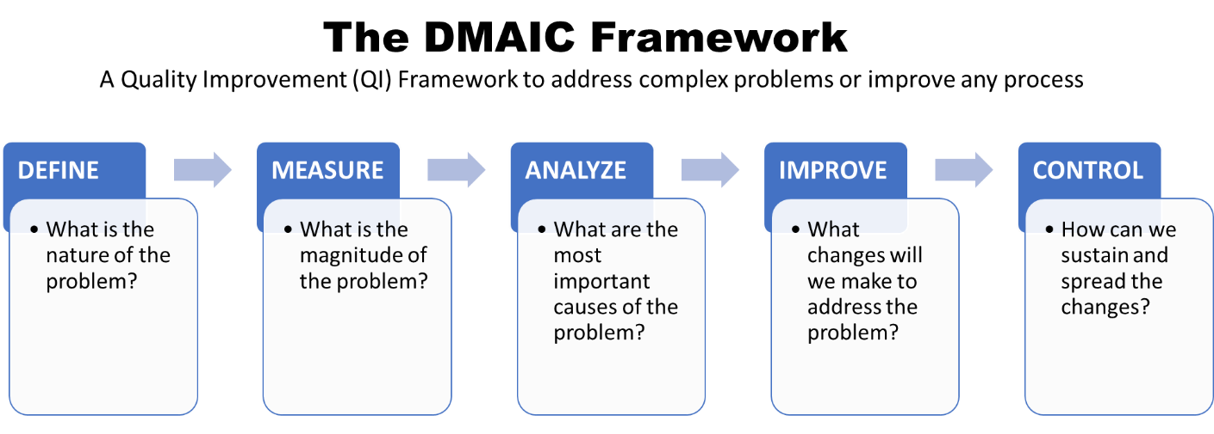

Phase | What Happens?
Define | - Create Problem Statement  - Define Goals & Aim  - Develop Timeline & Scope
Measure | - Select Metric  - Collect Data
Analyze | - Identify Root Cause
Improve | - Test and Select Changes
Control | - Monitor Process  - Communicate & Share Successes

THE MODEL FOR IMPROVEMENT (MFI)
A simple, yet powerful approach, using formal methods to test changes in the steps of a process, to achieve rapid and significant improvements (IHI, Model for Improvement).

The Model for Improvement consists of two components, which follow each other sequentially:
Part I | Answers to Three Fundamental Questions leading to the project Goals/Aim, Metric and Change
Part II | The Plan-Do-Study-Act (PDSA) Cycle, the iterative scientific method for achieving improvement through testing change, i.e., altering a step in a process and evaluating the impact of that alteration

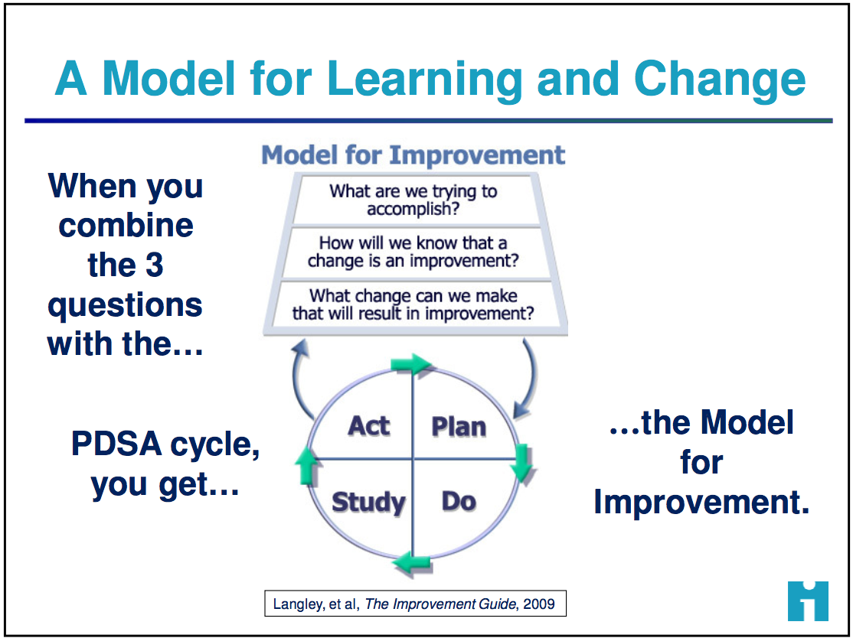

PART I: The Three Fundamental Questions

Three Fundamental Questions: | Deeper/Probing Questions | Desired Output
- What are you trying to accomplish? | - What outcome, in measurable terms, are you hoping to accomplish?  - Specify how good, for whom, and by when. | Goals & Aim Statement  Overarching, “big-picture” goal initially; then hone to an aim statement with a specific, measureable, time-bound outcome
- How will you know if a change is an improvement? | - What would be the most useful, meaningful metric to track?  - What metric provides the best measure of the desired goal? | Metric  A metric to complete the aim statement; Define the numerator and denominator for your metric
- What change will you make that will result in an improvement? | - Which changes will lead to the most significant improvement?  - Which changes will promote reaching the aim? Improve the metric? | Change/Intervention  Based on insights gained during process mapping, begin small tests of change, ultimately describing, selecting and taking the best intervention to scale.  Small tests of change allow rapid testing of various solutions before adopting the best intervention to addresses the root or underlying cause
Tips:
- Engage the team and stakeholders in determining the overall goal; i.e., what you want to accomplish.
- Answering question #1 and #2 is an iterative process, with each round gaining additional clarity and specification toward creating an AIM Statement
- When asked, everyone on the team should know the aim statement and elevator speech

PART II: The Plan-Do-Study-Act (PDSA) Cycle - Tests of Change Cycles

PLAN | - State the objective  - Make predictions  - Generate solutions  - Develop a data collection plan (who, what, where, when) | Tips:  - PDSA is not ‘one and done’, it consists of multiple iterative cycles. Think ahead & plan for the multiple cycles of testing over a wide range of conditions, collecting useful data from each test to guide the next one.  - Start small - Focus the initial test on the “one” – one doctor, one nurse, one laboratorian, one shift, one form, one day, etc.  - Start - Don’t wait around. Ask, “what change can we test by next Tuesday?”  - Keeping PDSA cycles updated on the Learning Board ensures that all involved know what changes are being tested
DO | - Run the test on a small scale  - Document problems & observations  - Collect and chart the data
STUDY | - Analyze the data  - Compare data to predictions  - Summarize learnings
ACT | - Determine what modifications you should make – adapt, adopt, or abandon  - Standardize the process  - Select the next cycle

Moving from the small test of change to widespread “big” change using ever widening PDSA Cycles
- Begin with small tests of change - focus on the “one”. As one PDSA cycle is complete, the next cycle begins.  - Continue to fine-tune tests – use lessons learned to “tweak” the test, and with each cycle, the involvement expands to involve another person/s, another shift, etc.  - Conduct wider scale tests - involve another group, another unit, another facility, etc.  - Standardize/Implement - When the change is proven to work reliably, it then becomes the new way to do work. The change is standardized into a new process and implemented.  - Move to the Control phase - where the change is monitored for sustainability and results are shared  - Implement at scale – if the change is applicable, it may be spread to other facilities or organizations | 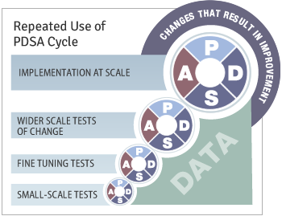

Templates:
- Worksheet for Testing Change
- Quality Improvement Project Outline

Associated Frameworks/Tools:
- DMAIC Framework
- Critical to Quality
- Standard Work
- Learning Board
- Elevator Speech

Worksheet for Testing Change
Aim:

Every goal will require multiple smaller tests of change
Describe your first (or next) test of change: | Person responsible | By When | Where

Plan
List the tasks needed to set up this test of change | Person responsible | By When | Where
Predict what will happen when the test is carried out | Measures to determine if prediction succeeds
Do Describe what actually happened when you ran the test
Study Describe the measured results and how they compared to the predictions
Act (three options)
- Adopt Standardize
- Adapt Describe what modifications to the plan will be made for the next cycle
- Abandon

Quality Improvement Project Outline

Team
ROLE | NAME/S
Champion/Sponsor/s | See Team Formation & Stakeholder Analysis
Team Leader
QI Expert / Coach
Data Manager
Front Line Team Member/s (One from each cadre)
Other Team Member/s
Scope of Project
Includes |  |  | Excludes
Specify first & last steps of process

Background/Context/Setting
For example: Country Information – Statistics, MOH efforts
Clinic Information - Size, location, staff – number and cadres, NGOs/partners involved, resources available, previous improvement efforts
Patient Information - Number of patients with HIV, number of tests, community needs,
Model for Improvement
THE THREE QUESTIONS |  | DEVELOP | YOUR ANSWERS
What are you trying to accomplish? |  | AIM | See Model for Improvement – 3 Fundamental Questions
How will you know if a change is an improvement? |  | METRIC
What change will you make that will result in an improvement? |  | CHANGE

Quality Improvement Project Outline

DMAIC
PHASE | KEY COMPONENTS | PROJECT DETAILS
Define | Gap (Problem Statement) | (15 words or less)
 | Aim | Increase/Decrease ___________ (metric) from ____ (baseline) to ____ (target) by ______ (date)
Measure | Baseline Measure | Numerator  ----------------------------------------------------------  Denominator
 | Data Source
 | Sample Size: | (need at least 25)
Analyze | Contributing Factor/s (See Analyze Tools): | See Analyze Tools
Improve | Intervention (Change): | See Model for Improvement - PDSA
 | Re-measure: | See Run Chart
Control | Project Owner: | Specify who & date of project transfer
 | Control Plan: | See Control Plan
 | Communication of Project Outcomes: | See Final Report & Storyboard Templates  Reported to Whom/Dates
 | Lessons Learned:
Accomplishments:
In one to two sentences, what did your team accomplish?

